

**WEBSITE FOOTPRINTING**

Information gathering for website: <https://www.lawinsider.com>

Including tags with errors and warnings: errors, warnings and notices. (Sitechecker.pro)

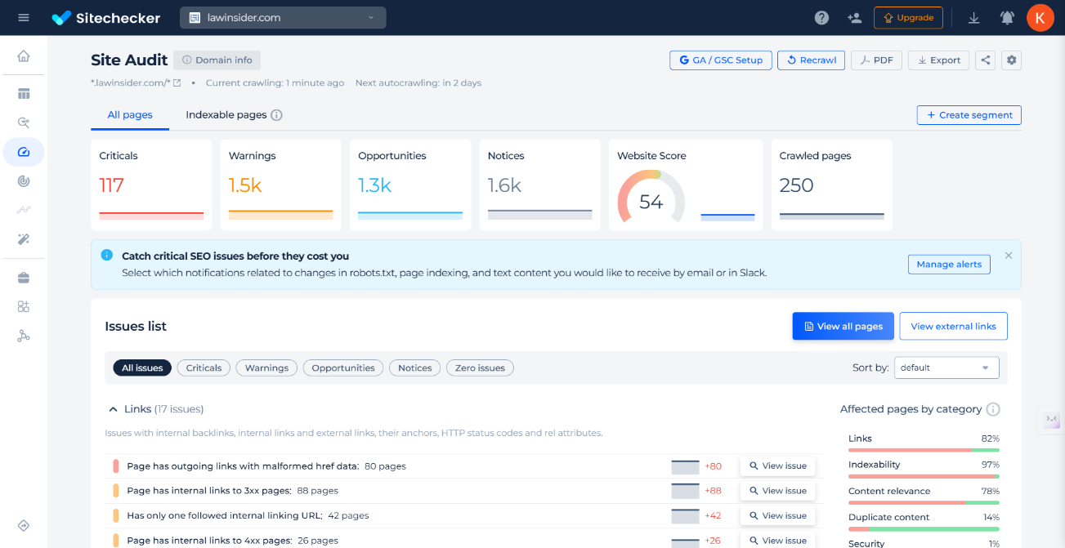

**Webpages Information:**

1. **Archive.org:**

[**Law Insider**](https://www.lawinsider.com) **is a comprehensive online platform designed for professionals, lawyers, and anyone working with legal documents. It is primarily known as a resource for accessing, analyzing, and managing contracts and legal clauses**

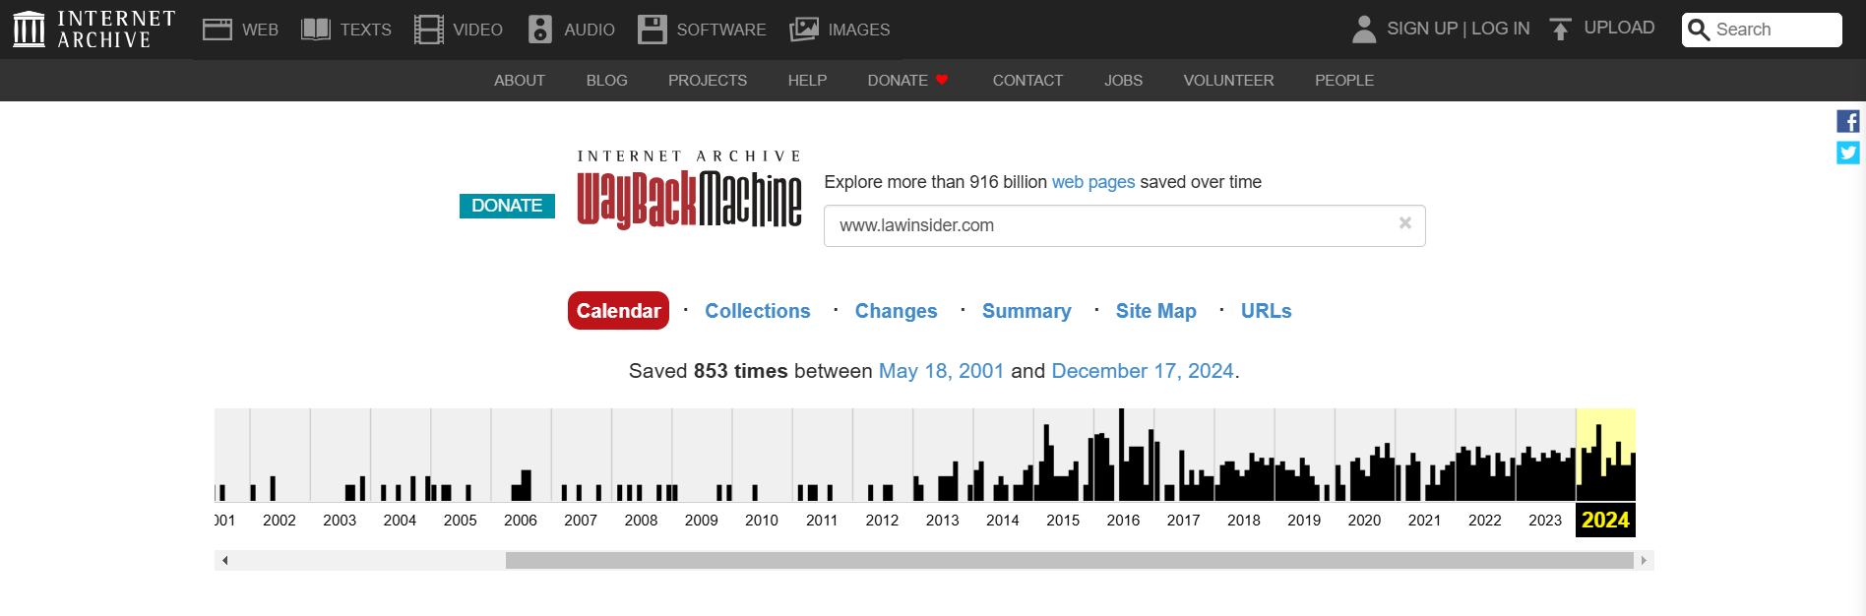

Law Insider has introduced Clause Finder™ AI Search, GPT integration, and Microsoft Word/Chrome extensions to streamline contract drafting. Additionally, it acquired one NDA to promote standardized legal templates among its users.

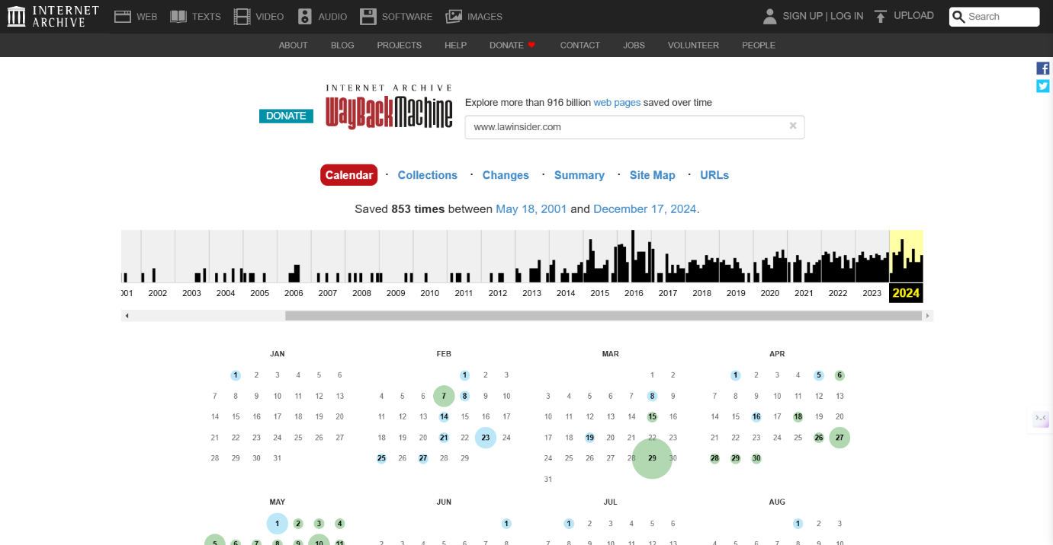



**No. of Changes made also indicated here:**

**2016-2024**

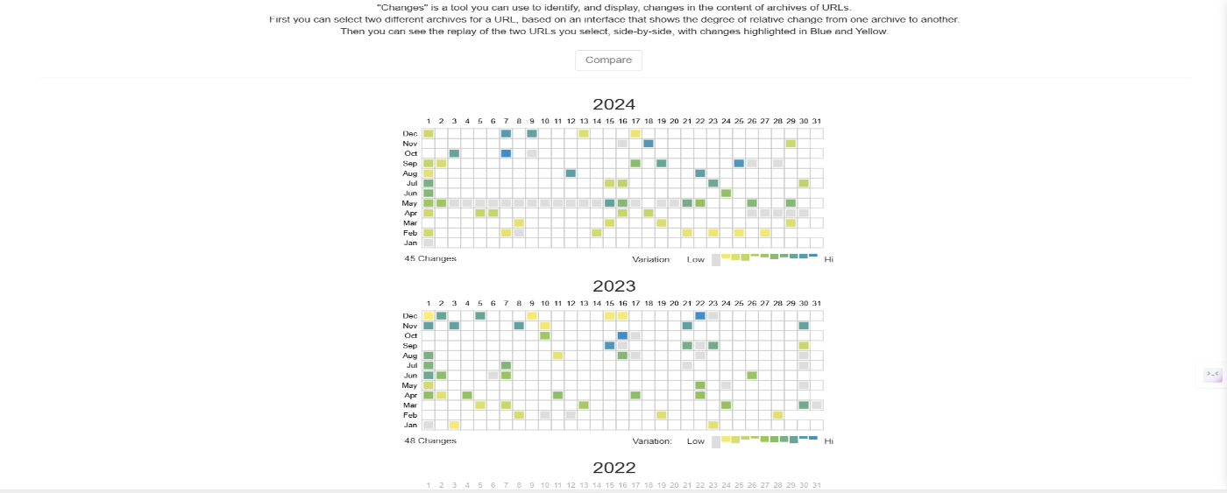









**Different Changes Summary.**

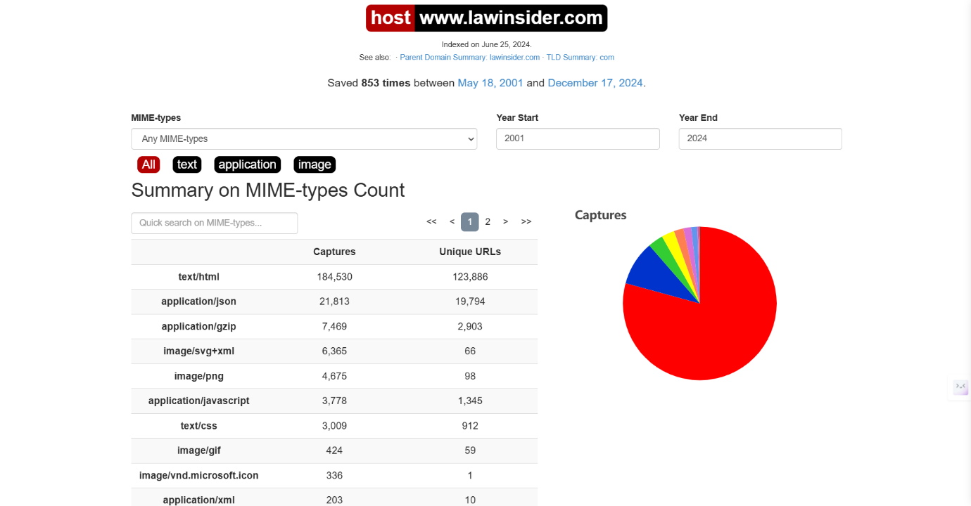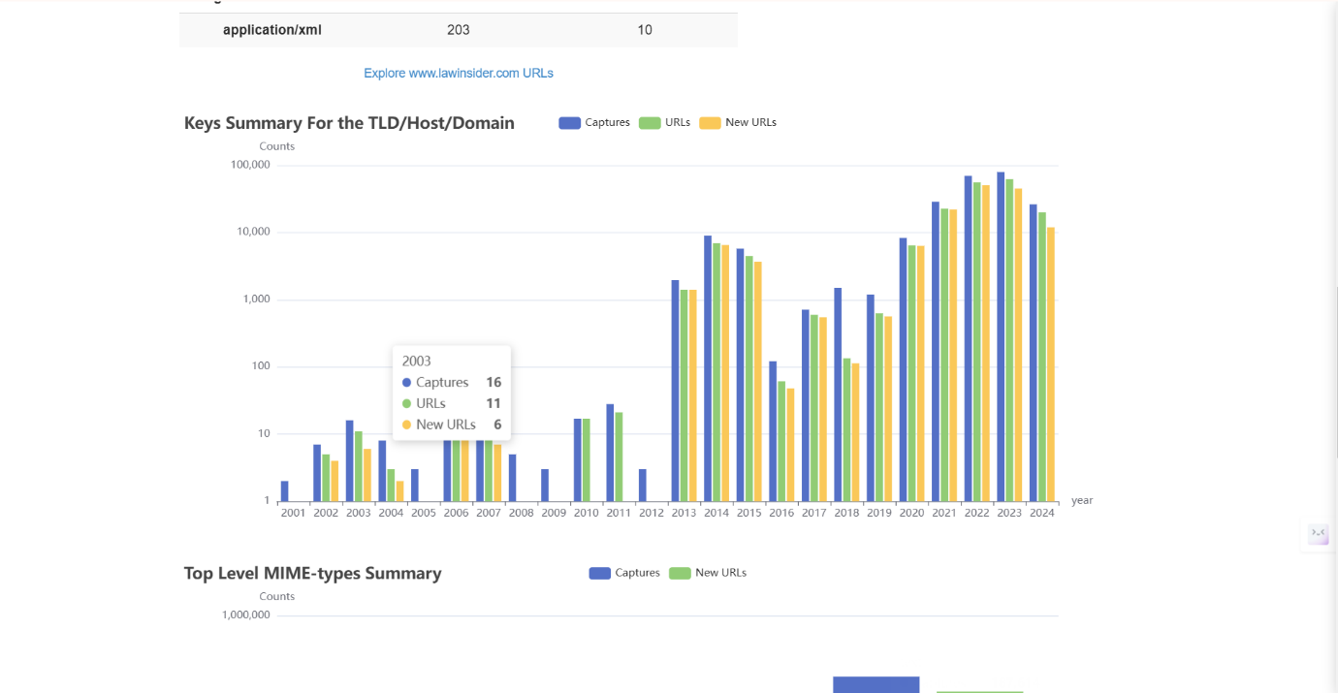

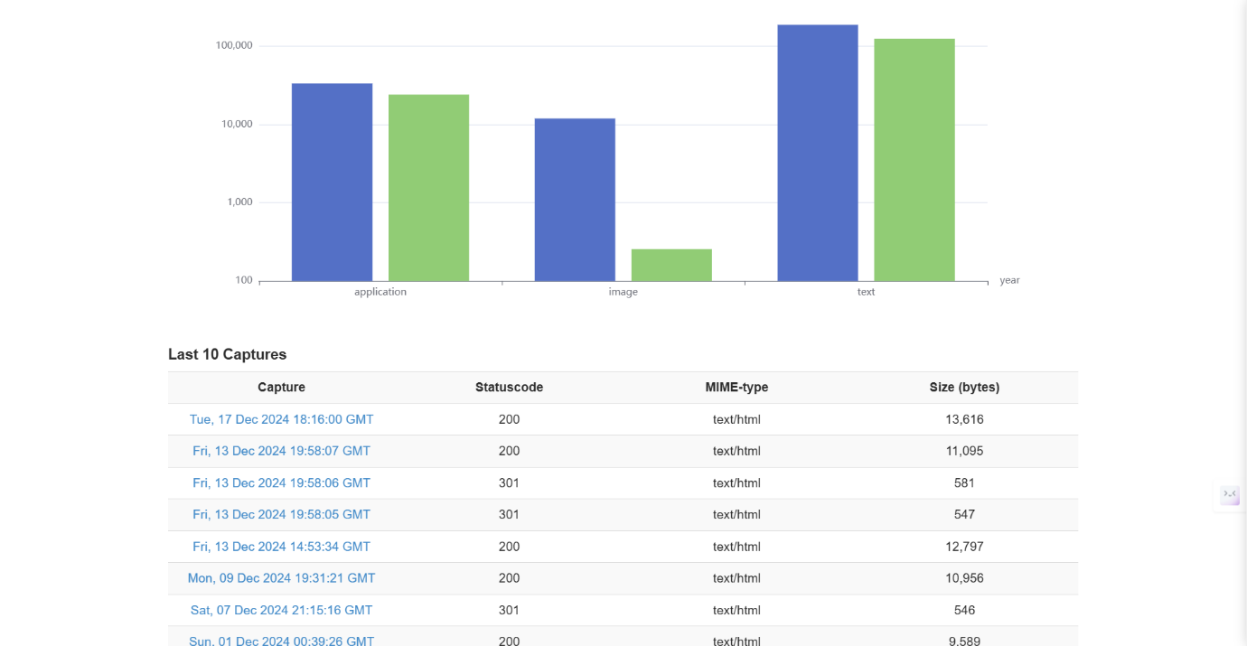

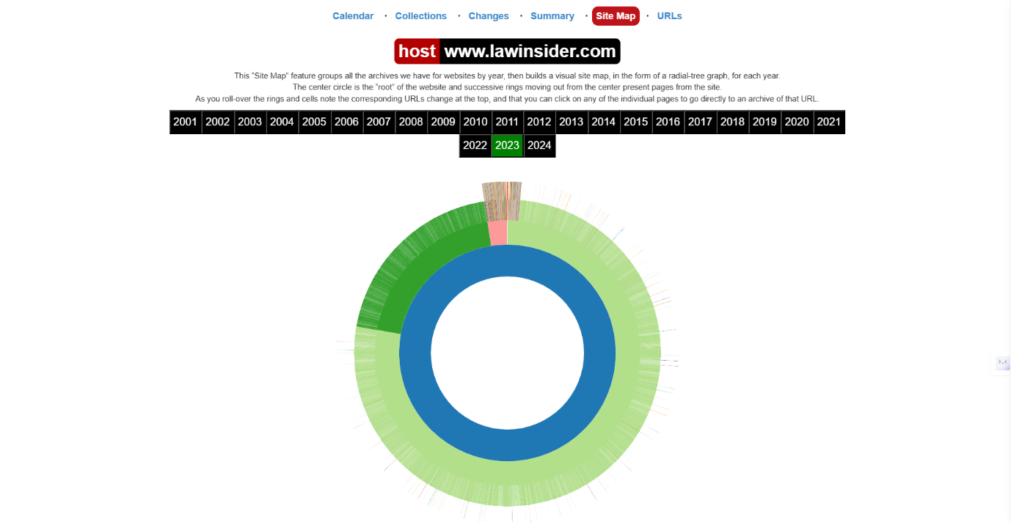

**2.Archive.is: Snapshot.**

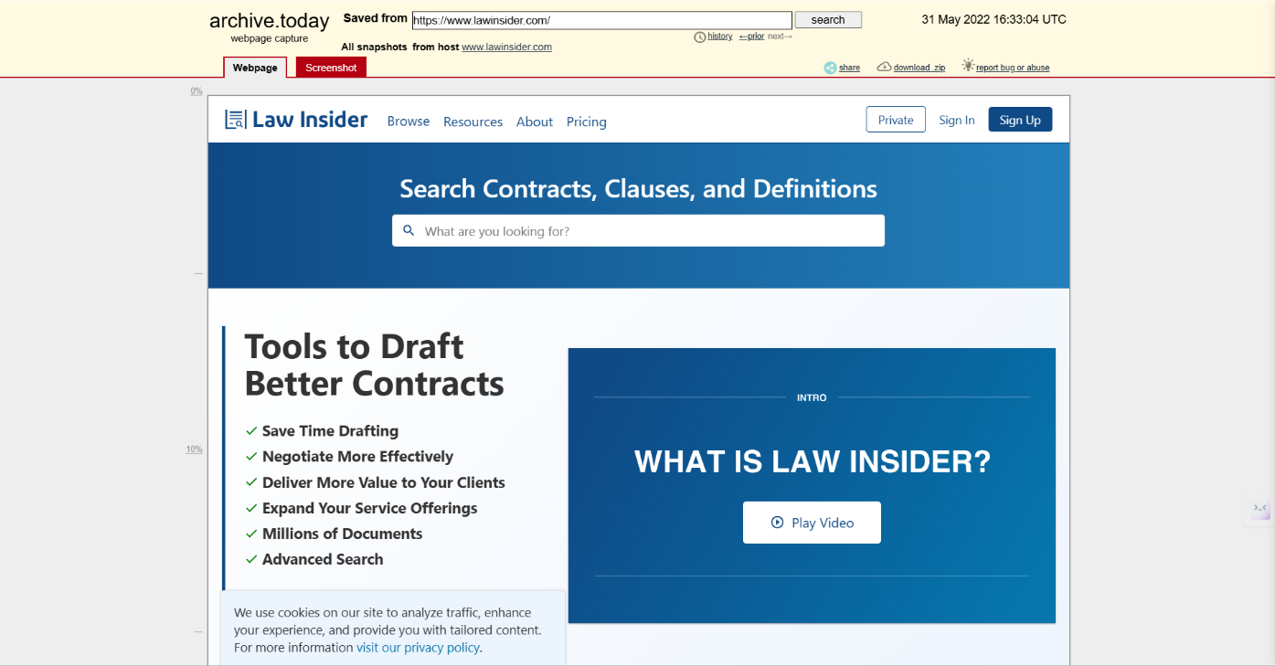

**Website Details and Owners Related Info**

1. **https://lawinsider.com**

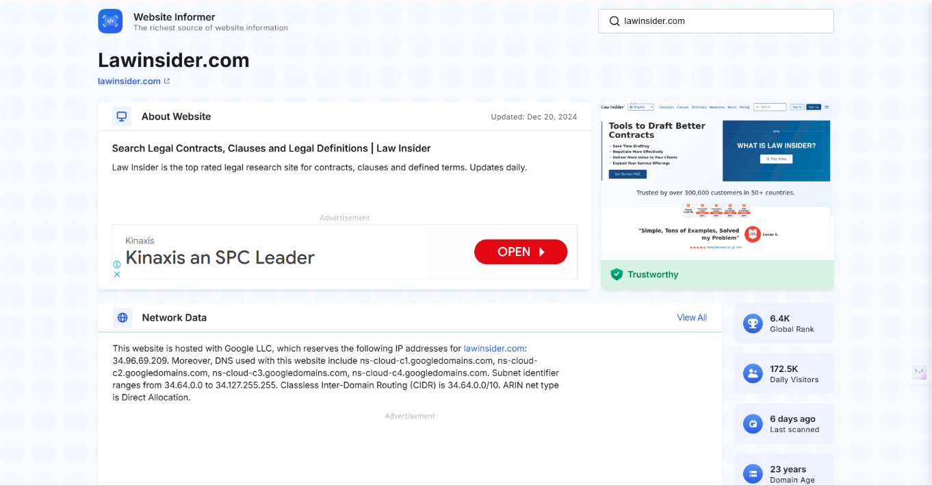

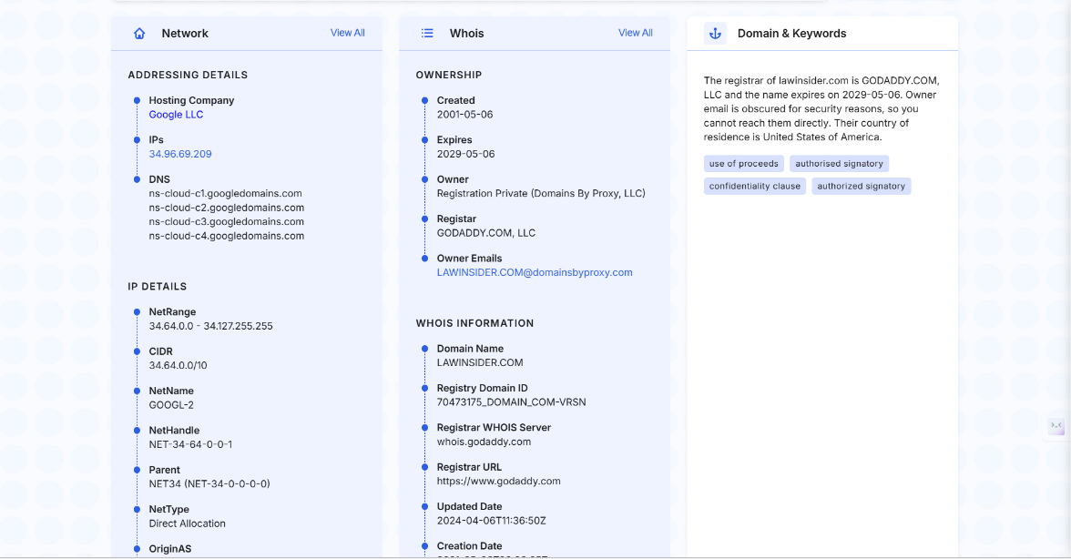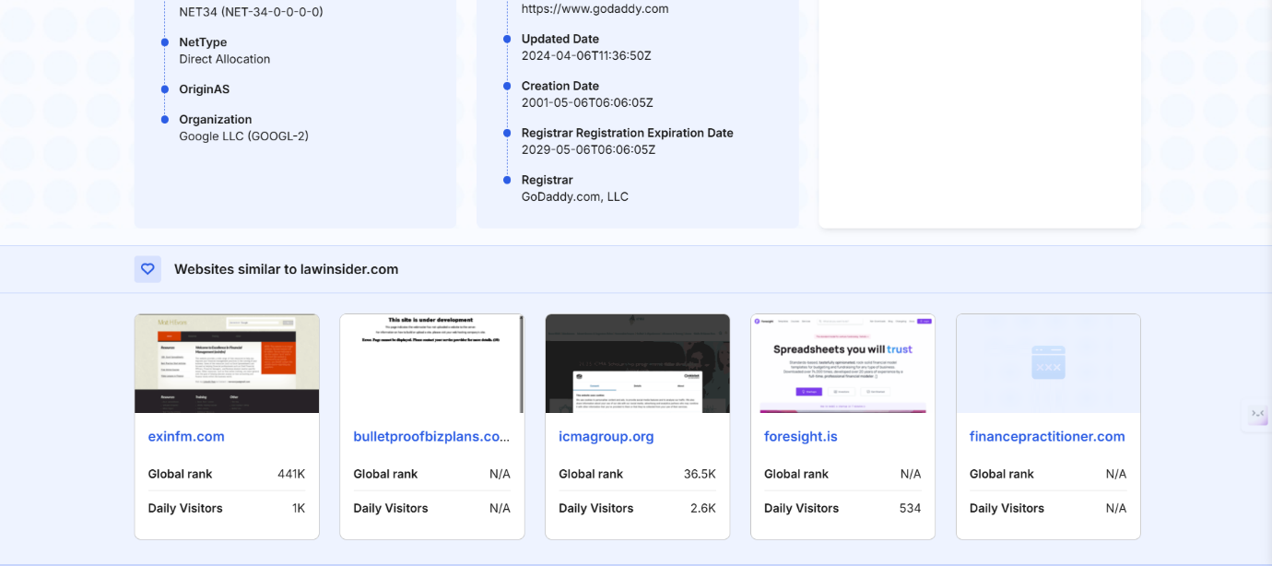

**TOOLS FOR WEBSITE FOOTPRINTING:**

**1. sitechecker.pro**

**2. websiteinformer.com**

**3. archive.org**

**4. archive.is**

**5. Httrack - (Mirroring illegal not used)**